Transition to adulthood with multiple disabilities.

Transitioning to adulthood is an exciting yet challenging period for people with multiple disabilities. During the process, they encounter many obstacles, therefore there is great need for consideration and planning. When people with multiple disabilities move to adulthood, we need to think about various aspects of their lives for example, their education, independence, employment, social integration as well as support systems. Moreover, it is of paramount importance that such people are given adequate opportunities, support and resources so that they achieve their full potential and live fulfilling lives.

What challenges do they face during transition?

Emotional
Social

Challenges

Physical
Communication

People with multiple disabilities may face obstacles in their social life. These may include failure to develop relationships in the community. Their participation in community activities may be limited due to stigma, discrimination and lack of physical accessibility. All this leads them to be socially excluded.
Emotionally, they may have depression, anxiety or low self-esteem. This may be due to the feelings of being different, loneliness and facing other societal barriers. They may find it difficult to cope with their disabilities and end up getting frustrated.
Physically, moving from one place to the other is challenging. Also, they might have other limitations in terms of sensory and fine motor skills are concerned. They experience fatigue due to their physical demands of their disabilities.
The ability to communicate their feelings, emotions and needs is limited. Some have difficulties in their motor skills. This means that they are not able to use their bodies or hands to use gestures to convey messages. Communication may be hindered by cognitive ability to understand and comprehend.

Can people with multiple disabilities be independent?

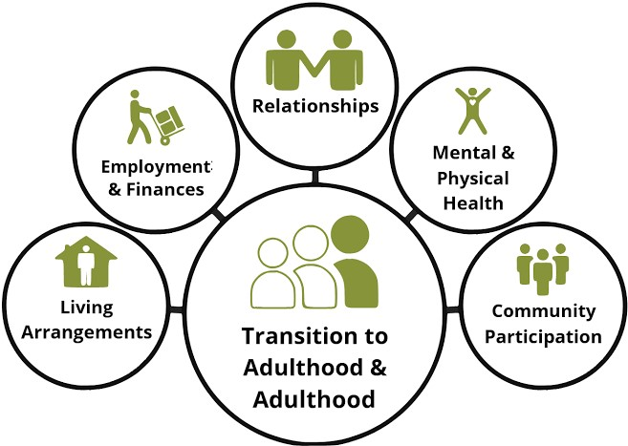
Independence for people with multiple disabilities depends on the severity of the disabilities. For those whose disabilities are not severe, are able to live independently. They are also able to make their own decisions. However, a lot is involved on the journey of independence. There are some success stories of independence of people with multiple disabilities. For example, an individual with Autism and is non verbal managed to communicate his wishes of going to college, getting a job and getting his own apartment- he is living in his own apartment. For those whose disabilities are severe, transitioning to adulthood and being independent is difficult. This is because some of them need to be under care for the rest of their lives. As such the care givers who are always the parents have fears such as, “Who will take care of my disabled child when I die?” “Will my child be able to be independent?”

What kind of support systems are there for successful transition?

Preparations for adulthood begins as early as possible (Council For Disabled Children). The immediate family is responsible for providing emotional and psychological support throughout the individual`s life. It is the family again that inculcates self-care and guidance and counselling.
The school also provides necessary support by developing the child`s skills. Vocational Training provides skills for self- reliance. These play a major role in the transition process. The young adult will be equipped with knowledge and later be employed in a factory or business. There are some rehabilitation programs and services that support people with multiple disabilities in their transition journey. Disability advocacy organizations are also available to render assistance to these people in terms of their human rights and wellbeing.
Creation of an inclusive environment enhances the livelihood of people with disabilities by providing support and opportunities.

References
Council for Disabled Children. “Into Adulthood.” councilfordisabledchildren.org.uk
“Living Independently with a Disability: Ben`s Journey.” https://youtu.be/OMI5-nT8bR4?si=mBy7Vt48p5PgAaW
“Young Adults with Disabilities Find Independence.” https://youtu.be/CQxjdOyR-8o?si=aStlTqLxmI0TOmhX
Transition to Adulthood and Adulthood image retrieved from https://images.app.goo.gl/V4H14JZTN8kj317d6

